Week 5 Assignment

Deadline 1 Week

Soundnap Home Page

Build the landing/home page of the Soundnap website you can find the page design in the assignment materials.

- Use positioning properties for the navbar and for the genre card to put text on top of the images.’

- The navbar should always remain on top even while scrolling.

- All buttons/links should have hover effects that highlight the element for a better user experience.

- Use the suitable CSS units to make sure to display the same number of cards per row (regardless of the screen size).

Bonus:

- Create the following effect on the cards on hover using opacity and z-index with positioning attributes.

- Make this effect smoother using CSS transitions.



DropBox UI

Create the Dropbox photos UI, that looks like the following:

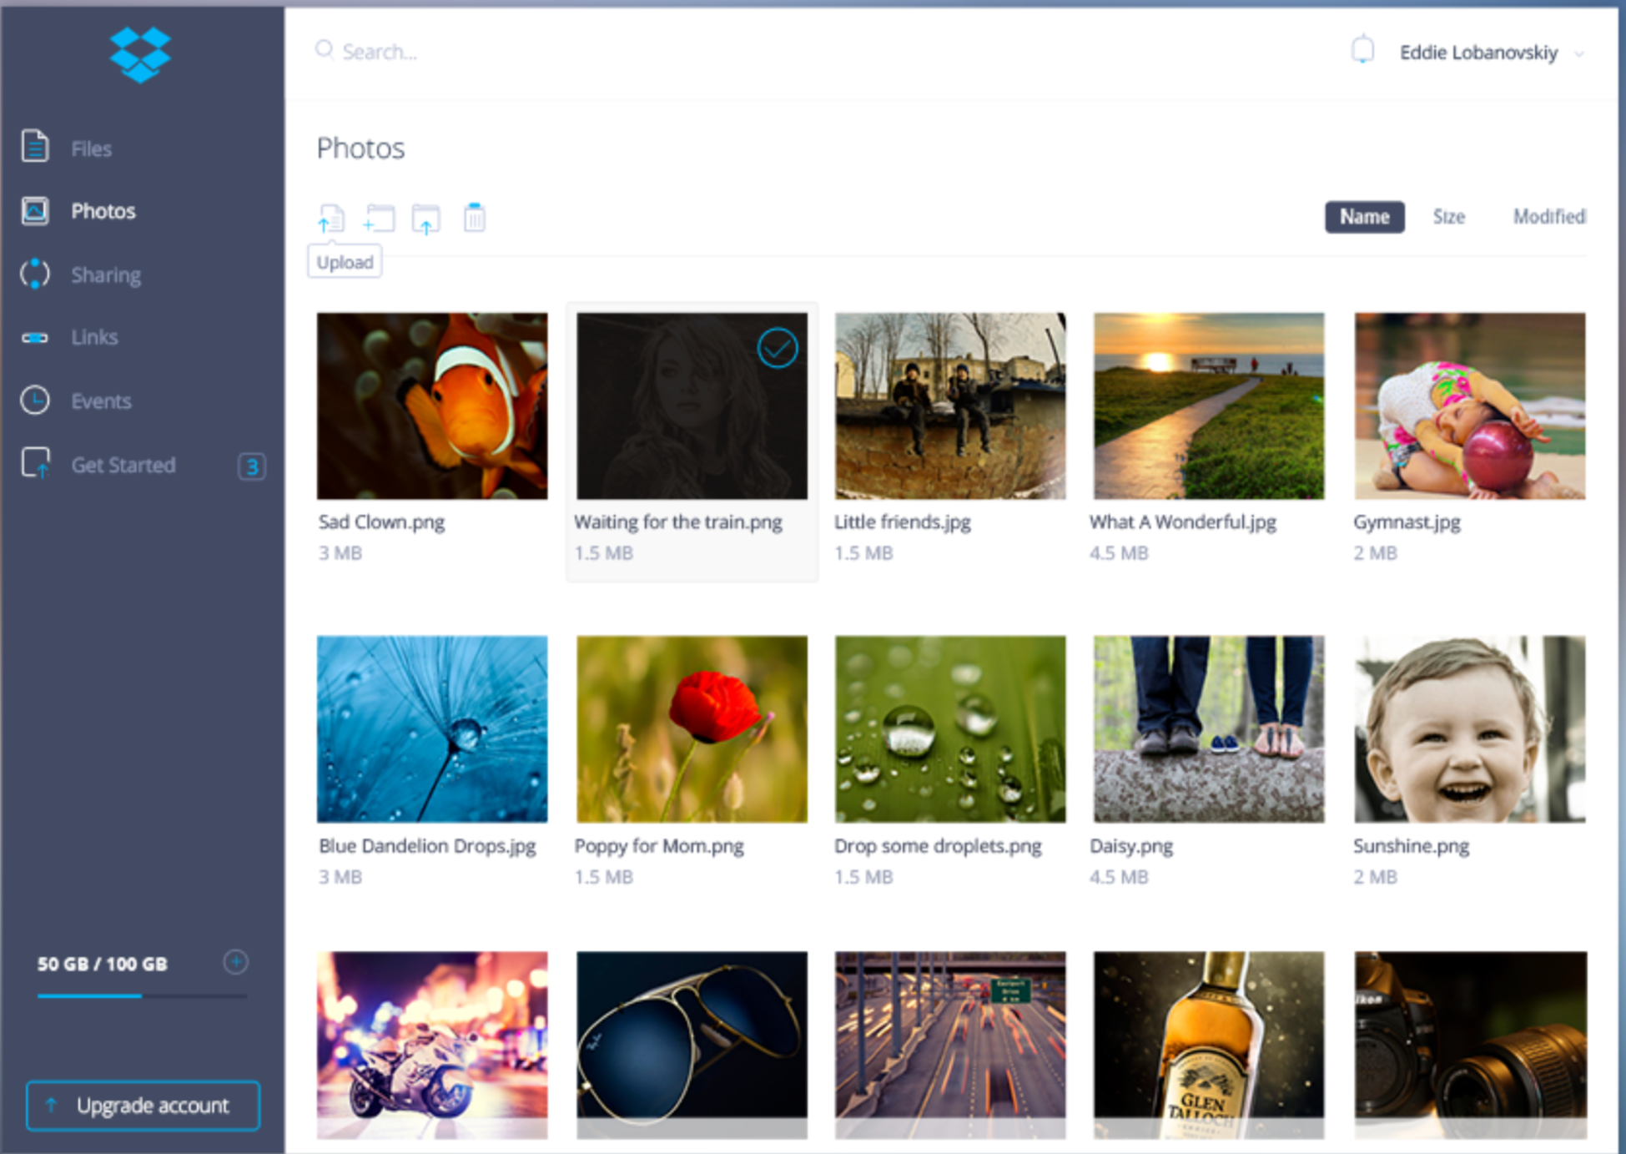

- The sidebar must not move.

- Look up the cursor property to change the cursor when it passes over any photo.

- Make use of the overflow property to make only the photos section scrollable while the rest of the page is not.

- Create the search input with the search image inside it (using positioning).
- Make sure that your design is as dynamic as possible (use appropriate units).

Note: You can use any images for the photo cards.
Bonus: Replace sidebar item images (files, photos, sharing,.. etc.) with icons.

